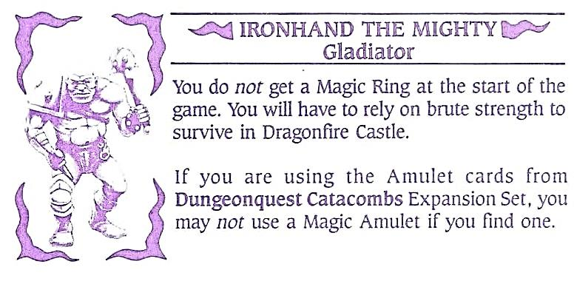

Place Ironhand The Mighty
Character Card Here

